Final

|  |  |  |  |  |
| --- | --- | --- | --- | --- |
|  | Buy |  |  | Sell |
| MCD | 100 |  | HXL | -122 |
| KO | 50 |  | GE | -75 |
| MMC | 50 |  | ILMN | -25 |
| MSFT | 25 |  | HUM | -50 |
| PLD | 25 |  |  |  |
|  |  |  |  |  |
|  |  |  |  |  |
| Total | 250 |  |  | -272 |

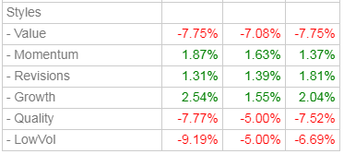

Draft

